Start of Block: Scenario1

Q1 Imagine your friend is preparing to apply for a job and they have asked you for help. The organization they are applying to has adopted a tool that analyzes four key components of the application to make a recommendation. These components are: CV, Cover Letter, LinkedIn profile, and interview score provided by the interviewer.

Your friend has provided their material to you and you want to help them by suggesting how your friend should allocate their remaining time to improving each of these factors. Your actionable suggestions are:

Improving the CV by rewriting and searching for a better template,

Improving the cover letter by having more experienced people comment on it,

Improving the LinkedIn profile by taking skill tests,

Studying common interview questions, and prepare structured and thoughtful responses.

The organization has indicated that each element's influence on the ultimate verdict varies in significance as shown below: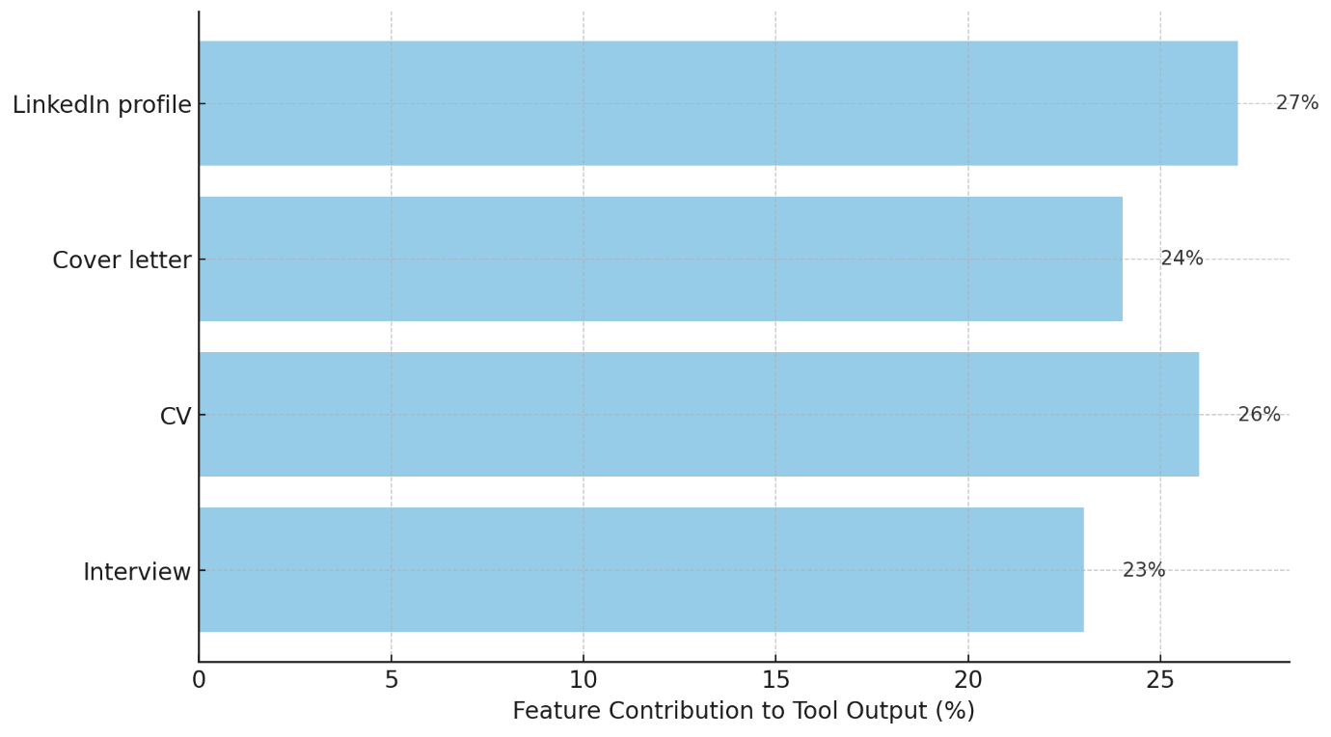

How would you suggest them distribute their time across the four components mentioned above? Insert the percentage of time you suggest they contribute to each component (percentage).

CV Preparation: : _______ (1)

Cover letter revision : _______ (2)

LinkedIn skills tests : _______ (3)

Practicing interview questions : _______ (4)

Total : ________

End of Block: Scenario1

Start of Block: Scenario2

Q2 Imagine your friend is preparing to apply for a job and they have asked you for help. The organization they are applying to has adopted a tool that analyzes four key components of the application to make a recommendation. These components are: CV, Cover Letter, LinkedIn profile, and interview score provided by the interviewer.

Your friend has provided their material to you and you want to help them by suggesting how your friend should allocate their remaining time to improving each of these factors. Your actionable suggestions are:

Improving the CV by rewriting and searching for a better template,

Improving the cover letter by having more experienced people comment on it,

Improving the LinkedIn profile by taking skill tests,

Studying common interview questions, and prepare structured and thoughtful responses.

The organization has indicated that each element's influence on the ultimate verdict varies in significance as shown below: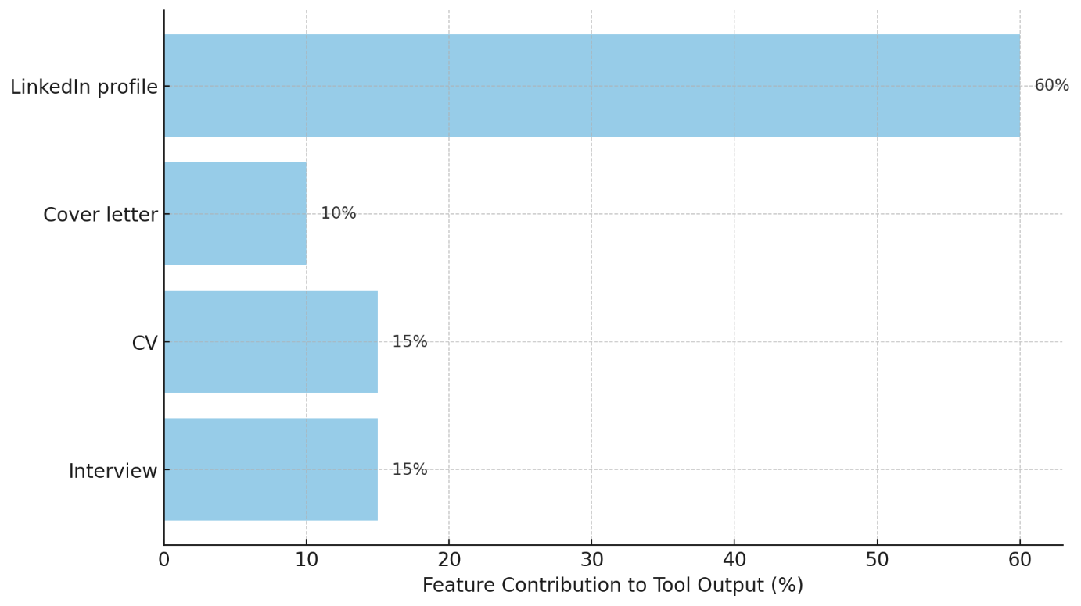

How would you suggest them distribute their time across the four components mentioned above? Insert the percentage of time you suggest they contribute to each component (percentage).

CV Preparation: : _______ (1)

Cover letter revision : _______ (2)

LinkedIn skills test : _______ (3)

Practicing interview questions : _______ (4)

Total : ________

End of Block: Scenario2

Start of Block: Satisfaction

|  |  |  |  |  |  |
| --- | --- | --- | --- | --- | --- |
|  | Extremely difficult (1) | Somewhat difficult (2) | Neither easy nor difficult (3) | Somewhat easy (4) | Extremely easy (5) |
| Your answer: (1) |  |  |  |  |  |

Q3 The system was easy to use

|  |  |  |  |  |  |
| --- | --- | --- | --- | --- | --- |
|  | Strongly disagree (1) | Somewhat disagree (2) | Neither agree nor disagree (3) | Somewhat agree (4) | Strongly agree (5) |
| Your answer: (1) |  |  |  |  |  |

Q4 The explanation of how the tool works was useful for my goals

|  |  |  |  |  |  |
| --- | --- | --- | --- | --- | --- |
|  | Extremely dissatisfied (1) | Somewhat dissatisfied (2) | Neither satisfied nor dissatisfied (3) | Somewhat satisfied (4) | Extremely satisfied (5) |
| Your answer: (1) |  |  |  |  |  |

Q5 Rate your satisfaction with the explanation

End of Block: Satisfaction

Start of Block: Understanding

|  |  |  |  |  |  |
| --- | --- | --- | --- | --- | --- |
|  | Not well at all (1) | Slightly well (2) | Moderately well (3) | Very well (4) | Extremely well (5) |
| Your answer: (1) |  |  |  |  |  |

Q6 I understand the explanation of how the tool works

|  |  |  |  |  |  |
| --- | --- | --- | --- | --- | --- |
|  | Very confident (1) | Somewhat confident (2) | Neither confident nor unsure (3) | Somewhat unsure (4) | Very unsure (5) |
| Your answer: (1) |  |  |  |  |  |

Q7 How confident are you in your answer?

|  |  |  |  |  |  |
| --- | --- | --- | --- | --- | --- |
|  | Extremely unlikely (1) | Somewhat unlikely (2) | Neither likely nor unlikely (3) | Somewhat likely (4) | Extremely likely (5) |
| Your answer: (1) |  |  |  |  |  |

Q8 Assume the organization's tool gives the following weights: CV (30%), Cover Letter (25%), LinkedIn (15%), and Interview (30%). If your friend spends equal amounts of time (25% each) on all components, how likely do you think it would be for them to receive a positive recommendation?

End of Block: Understanding

Start of Block: Trust

|  |  |  |  |  |  |
| --- | --- | --- | --- | --- | --- |
|  | Very safe (1) | Somewhat safe (2) | Neither safe nor dangerous (3) | Somewhat dangerous (4) | Very dangerous (5) |
| Your answer: (1) |  |  |  |  |  |

Q9 Do you think that the system is trustworthy?

|  |  |  |  |  |  |
| --- | --- | --- | --- | --- | --- |
|  | Definitely not (1) | Probably not (2) | Might or might not (3) | Probably yes (4) | Definitely yes (5) |
| Your answer: (1) |  |  |  |  |  |

|  |  |  |  |  |  |
| --- | --- | --- | --- | --- | --- |
|  | Click to write Scale Point 1 (1) | Click to write Scale Point 2 (2) | Click to write Scale Point 3 (3) | Click to write Scale Point 4 (4) | Click to write Scale Point 5 (5) |
| Your answer: (1) |  |  |  |  |  |

Q10 Is the tool efficient at what it does?Q11 What is your confidence in the tool?

End of Block: Trust

Start of Block: Task Performance

|  |  |  |  |  |  |
| --- | --- | --- | --- | --- | --- |
|  | Extremely difficult (1) | Somewhat difficult (2) | Neither easy nor difficult (3) | Somewhat easy (4) | Extremely easy (5) |
| Your answer: (1) |  |  |  |  |  |

|  |  |  |  |  |  |
| --- | --- | --- | --- | --- | --- |
|  | Very unsuccessful (1) | Somewhat unsuccessful (2) | Neither successful nor unsuccessful (3) | Somewhat successful (4) | Very successful (5) |
| Your answer: (1) |  |  |  |  |  |

|  |  |  |  |  |  |
| --- | --- | --- | --- | --- | --- |
|  | Very low (1) | Somewhat low (2) | Neither low nor high (3) | somewhat high (4) | Very higher (5) |
| Your answer: (1) |  |  |  |  |  |

Q12 How difficult was the task?Q13 How successful were you at the task?Q14 How mentally demanding was the task?

End of Block: Task Performance